Restaurant Franchise Profits – Linear Regression
1-Page Summary Report | Business Analytics / ML Foundations | Extended from Coursera C1_W2

Problem Statement
A restaurant-franchise CEO must decide which new cities will generate higher monthly profits. Historical data (97 cities) link population size (in 10 000s) to average monthly profit (in $10 000s). Negative profits indicate losses. The goal is to fit a univariate linear model f(x) = w·x + b, learn optimal parameters via gradient descent, and produce concrete dollar forecasts for candidate cities of 35 000 and 70 000 inhabitants.

Solution Strategy
1. Load and visualise the classic population–profit data set.
2. Implement the mean-squared-error cost J(w,b) both with an explicit loop (pedagogical) and a fully vectorised NumPy version.
3. Derive and code the analytic gradients ∂J/∂w and ∂J/∂b.
4. Run batch gradient descent (α = 0.01, 1 500 iterations) from a zero initialisation.
5. Diagnose convergence with a cost-history plot; verify the fit against the closed-form solution.
6. Produce business predictions and a short hyper-parameter / noise simulation; prepare audience-specific narratives (CEO vs data scientist).

Solution
Gradient descent converges to w ≈ 1.166, b ≈ –3.630. The model predicts a monthly profit of approximately $4 520 for a city of 35 000 people and $45 342 for a city of 70 000 people. The cost falls monotonically from ~32 to ~4.48; R² of the final fit is high and residuals are well-behaved. Vectorised and loop implementations produce identical numeric results. A short simulation confirms that modest changes in learning rate still recover essentially the same parameters, while added noise increases residual variance as expected.
Figure – Data scatter, fitted line + cost history, and workflow
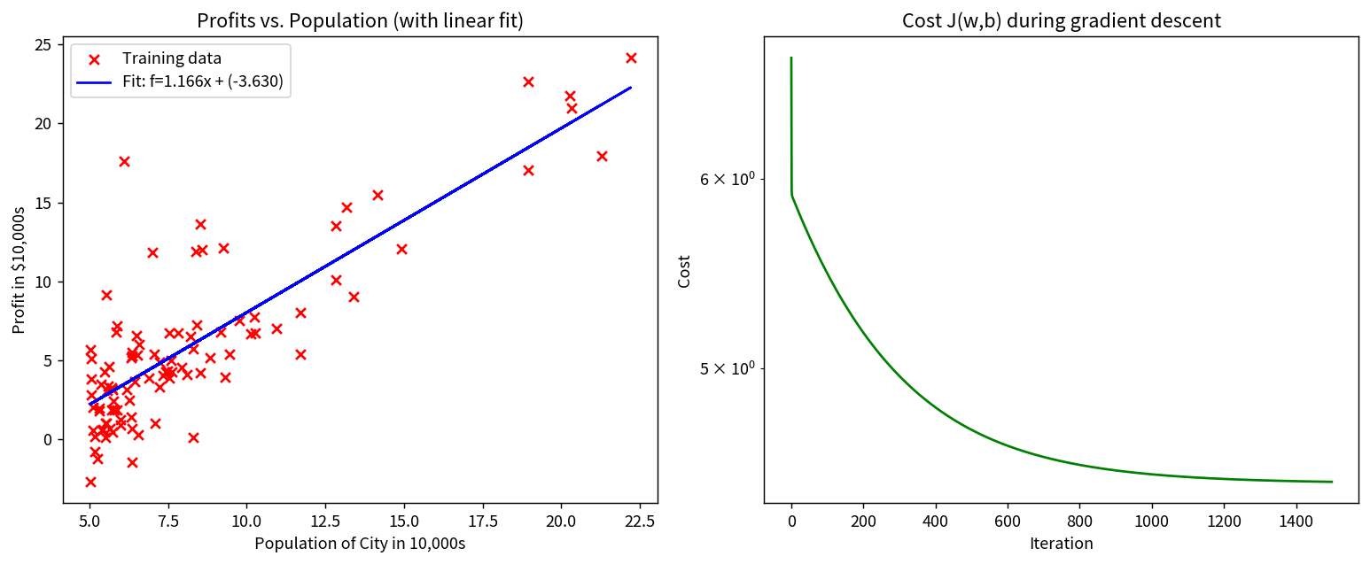

Key Takeaways
• Univariate linear regression remains the simplest, most transparent response model for managerial forecasting when the relationship is approximately linear.
• Implementing cost and gradients from first principles builds deep understanding; the vectorised forms are then trivial to deploy in production.
• Always plot the cost trajectory – a rising or oscillating cost is the earliest warning of an inappropriate learning rate.
• Audience adaptation is essential: executives need the two dollar forecasts and one clean chart; technical peers need residual diagnostics, R² and code alternatives.
• The same workflow (load → cost → gradient → GD → diagnose → predict → simulate → narrate) is a reusable template for any single-feature linear-regression problem.

